UNITED WITH THE NATIONAL FRENCH POLICE

You are here

[Home](https://www.cepol.europa.eu/) » [Media](https://www.cepol.europa.eu/media) » [News](https://www.cepol.europa.eu/media/news) » United with the National French Police

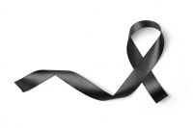

03 October 2019

We strongly condemn the act of violence and murder of our fellow police colleagues in the French capital.  
Together at CEPOL, we pay tribute to those killed and seriously injured in Paris knife-man attack.

On behalf of all of us involved in training European of law enforcement community, we express a message of solidarity to the families of victims, to law enforcement community of Paris and France, and all those who dedicate their lives to provide security to our citizens.

Our community stands united against violence and acts of terror.

The Executive Director of the European Union Agency for Law Enforcement Training has shared letter of condolence with the French police national today.